**MSC  Opera 18 Noches**

**Posicionamiento en Genova Italia**

**24 Marzo 2018  al 11 Abril,**

**Saliendo:**Havana, Cuba, Phillipsburg, St Maarten (Dutch part), St. John Antigua and Barbuda, Virgin Islands ( British), Funchal Portugal, Cadíz Spain, Genova Italy

**Cabina Doble Int Cat "I1" p/p $48 800 MXN**

Incluye:

18 Noches de hospedaje a bordo del MSC Opera

-Todos los alimentos a bordo

-Café, té y Agua en todo el recorrido.

-Diversión y Actividades recreativas a bordo.

-Traslado a la Terminal de Cruceros Sierra Maestra en la Habana

-11 Abril Traslado Muelle en Génova al hotel en Génova.

-02 Noches de hospedaje en Génova Abr.11/13- con Desayunos.

-Traslado al aeropuerto

-Boleto Aéreo 13 Abril  Génova /Cancún vía Munic

-Visa cubana

Boletos aéreos incluidos: Ruta de Retorno:

**-INTERJET 4902 24 MARZO Cancún La Habana 0840 1045**

-L**UFTHANSA 1947 13APR GENOVA MUNICH 0640 0755**

**-CONDOR 2152 13APR MUNICH CANCUN 1430 1945**

-Precios sujetos a espacio y a disponibilidad,

No lo piense demasiado!!!!

Ruta del Msc Opera, saliendo desde la Habana:

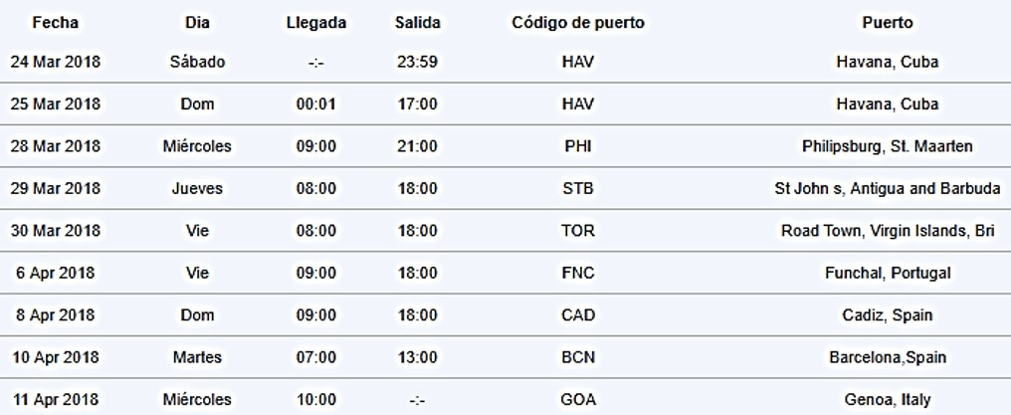

Plan de bebidas opcionales para comprar hasta 30 días ANTES de la fecha de salida:

Pueden comprar 1 cuponera o el número de cuponeras que les acomode:

|  |  |
| --- | --- |
| **WINE & WATER PACKAGE CLASSIC**  **129 {** | 7 bottles of wine and 7 bottles of mineral water 1L to accompany your meals in the main dining room . You can choose your wines from a dedicated selection of most popular wine varieties, like chardonnay, sauvignon blanc, riesling, pinot gris, merlot, cabernet sauvignon, chianti, pinot noir, prosecco). The wines included in the package are available only in the main restaurants. |

|  |  |
| --- | --- |
| **BEER & WATER PACKAGE**  **69 {** | 14 large draught beers and 7 bottles of mineral water 1L for consumption in bars, restaurants and self-service buffet. |

|  |  |
| --- | --- |
| **SOFT DRINK PACKAGE**  **44 {** | 14 canned sodas or fruit juices. The drinks included in this package can be consumed in bars, restaurants and self-service buffet. |

|  |  |
| --- | --- |
| **ALL-INCLUSIVE RESTAURANT & BAR DRINK PACKAGE A.**  **26 { por día**  ***Esta opción deberá ser comprada por el total de ocupantes en la cabina*.** | Unlimited consumption of spirits, liqueurs, aperitifs and cocktails from the bar list, dedicated selection of wines by the glass, draught beer, sodas, fruit juices, mineral water, espresso, cappuccino and other classic hot drinks, and takeaway ice cream in a cone or cup. The drinks included in package can be consumed in all bars, self-service buffet and restaurants including the specialty restaurants. The following items are not included in this offer: tobacco, champagne, bottles of wine and sparkling wine, premium spirit brands, drinks from the minibar and water provided in your cabin, souvenir glasses and food served in specialty bars and restaurants. Other excluded items are detailed in the onboard Bar List, indicated with an asterisk.  **TERMS & CONDITIONS:** The package is for personal use only and valid for one order at a time. The ID card is non-transferrable. Abusing the terms of the all-inclusive package may cause the service to be withdrawn and the remaining days not to be refunded. The price of the package applies to each day of the cruise except for the day of disembarkation; the package cannot be purchased on daily basis. Once activated on board, the package cannot be interrupted and refunded. The package must be booked by all guests occupying the same cabin, or just travelling together and wishing to eat at the same table, including minors who must book the Child version of the package. |

-Las propinas se pagan a bordo del barco:

10 { por día x 18 días = $3 960MXN por persona al tipo de cambio del barco.

Visa Cubana NO INCLUIDA

-Depositos:

- Al momento de reservar son $600 { por persona.

- El boleto aéreo INTERCONTINENTAL se expide simultáneamente y se requiere el pago total $14 040MXN.

-El boleto aéreo Cancún Habana se expide simultáneamente $3 024 pesos

Para garantizar el precio se requiere el pago total. Ya que el tipo de cambio varía constantemente.

**Todos los precios están sujetos a cambios sin previo aviso.**